Python class diagram for project IFB299-55

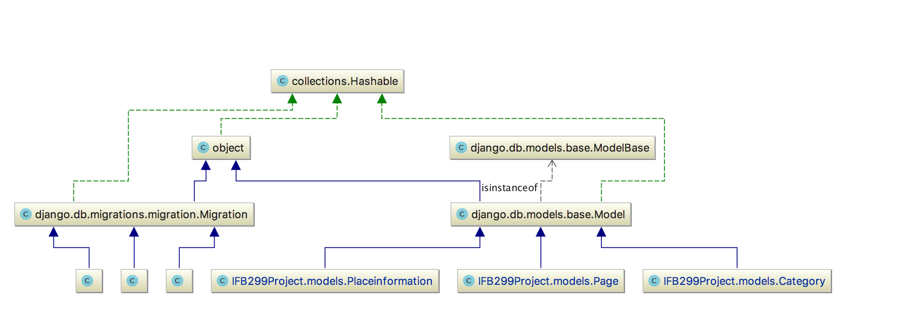This is a class diagram for our project which shows 2-tier structure of our project. As I researched related to Django web-project structure. It is convenient to use multi- layered structure because which gives better understanding on project for other people and it’s easy to manage. Because of layered structure we can easily identify problems. Once you identify problems it’s very easy to resolve it.